Ideation Phase Brainstorm & Idea Prioritization
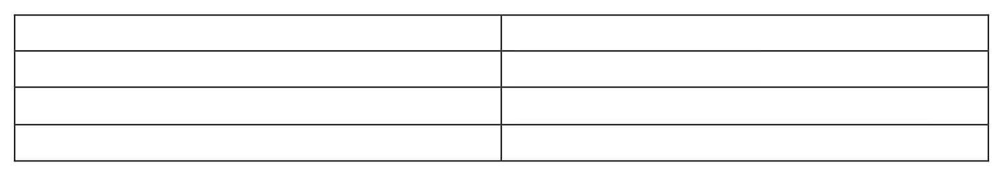
Date
Team ID
Project Name
Maximum Marks

4
Marks

2
Nov 2025

NM2025TMID02665

MedicalInventoryManagement

Medical Inventory Management:
The Medical Inventory Management System is designed to simplify and organize the handling of medical supplies in healthcare facilities. The main idea behind this project is to ensure that hospitals, clinics, and pharmacies can efficiently manage their stock of medicines, equipment, and consumables without facing shortages or overstocking. This system keeps accurate records of all medical items, including their quantities, suppliers, purchase details, and expiry dates. It helps healthcare staff track the availability of essential products and receive timely alerts for items that are low in stock or nearing expiry.
By implementing this solution in Salesforce, the management of medical resources becomes more transparent and automated. The system supports better decision-making by providing real-time insights into inventory usage, ensuring that critical medical supplies are always available when needed. Overall, this project aims to reduce waste, improve operational efficiency, and enhance the quality of healthcare services through effective inventory control.
Step-1:TeamGathering, Collaboration and Select the Problem Statement:
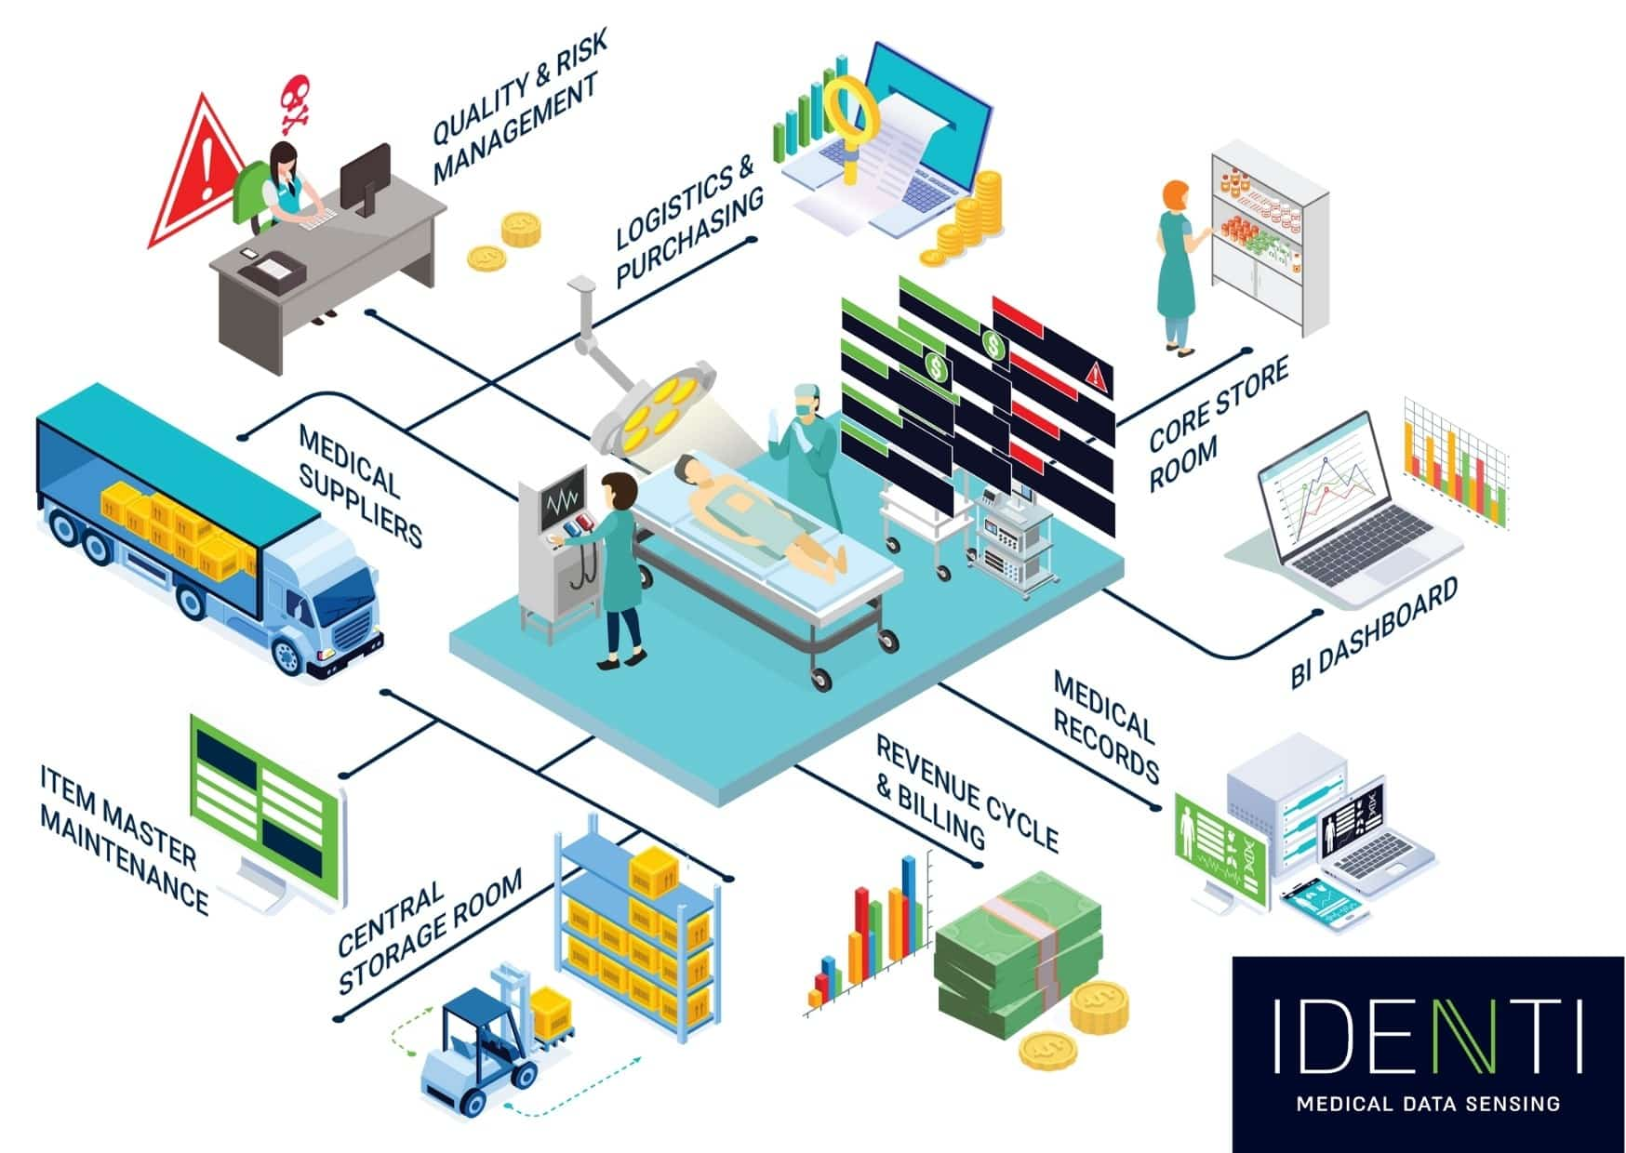
Step 2: Brainstorm, Idea Listing and Grouping:
- Brainstorm:
The brainstorming stage focused on identifying the major problems faced by healthcare organizations in managing their medical inventory. The discussion centered around common issues such as inaccurate stock data, expired medicines, delayed procurement, and lack of real-time visibility. Various possible improvements were considered, such as automating stock updates, generating alerts for low inventory, and maintaining supplier information efficiently.
The goal of this brainstorming process was to design a system that could minimize manual work, ensure data accuracy, and streamline the overall inventory management process through the Salesforce platform.
- Idea Listing:
Based on the brainstorming session, several potential ideas were proposed to enhance medical inventory operations:
  - Maintain a centralized database of all medical products and equipment.
  - Track the quantity, expiry date, and supplier details of each item.
  - Implement automatic alerts for low stock and expiring items.
  - Generate detailed purchase and usage reports for analysis.
•
Provide role-based access for administrators, pharmacists, and staff.
•
  - Automate the procurement process through integrated workflows.
Providing reports and dashboards for managerial insights into medical stock levels, consumption patterns, and overall inventory performance.
- Grouping of Ideas:
After listing the ideas, they weregrouped into categories for better organization and clarity:
- Inventory Management:
Includesideasrelatedtotrackingstock levels, expiry dates, and product details.
- Procurement and Supplier Management:
Coversideasabouthandlingpurchaseorders,supplier records, and reordering processes.
- Automation and Alerts:
Focusesonideasthatimproveefficiency through automated notifications and workflows.
- Reporting and Analytics:
Includesthegenerationofstock,usage, and purchase reports for management insights.
- User Access and Security:
Ensuresrole-basedpermissionsand secure access to sensitive inventory data.
Step-3: Idea Prioritization
After grouping the ideas, each concept was carefully analyzed based on its importance, feasibility, and impact on improving the efficiency of medical inventory operations. The main goal was to focus on the features that would bring the most value to the system in its initial stage. High-priority ideas included developing a centralized database to manage all medical items, implementing automated alerts for low stock and expiring products, and enabling secure role-based access for different users. These features were considered essential for the smooth functioning of the system. Medium-priority ideas involved managing supplier information, automating the procurement process, and tracking purchase orders, which could be introduced once the core functionalities were stable. Low-priority ideas, such as advanced analytics dashboards and external system integrations, were identified as future enhancements to improve performance and scalability. This prioritization helped create a clear roadmap for phased implementation, ensuring that the project began with a strong, practical foundation.

